COMP 2160_01 Mobile App Development

Application Mock-Up Doc & Prototype Screen Shots

**Team O**

**Digest This Date**

Digest This Date is just a placeholder name for the app we are developing. This is an early stage mock-up showing some of the basic functions our team plans on adding to out app. The Prototype designs are not final but more just place holders to show the basic needs our app will for fill for our user. The following three pages will show screen shots of the Prototype created and a link to the YouTube Video of the live demo of the prototype.

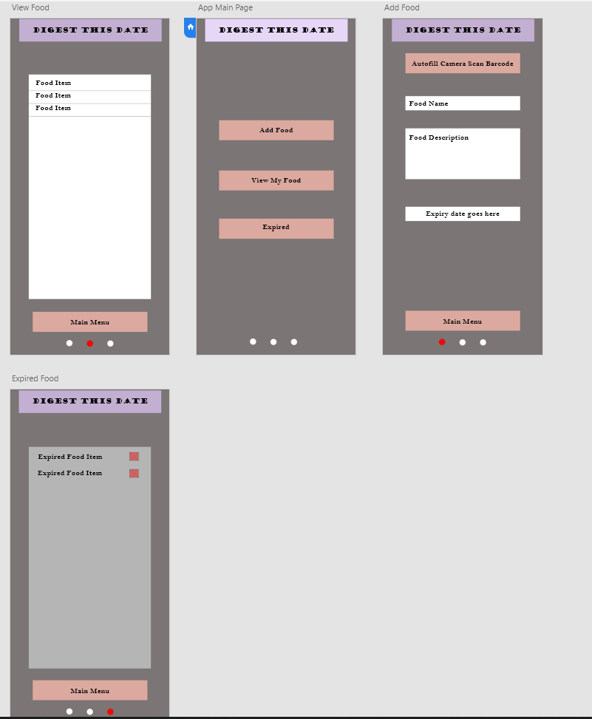

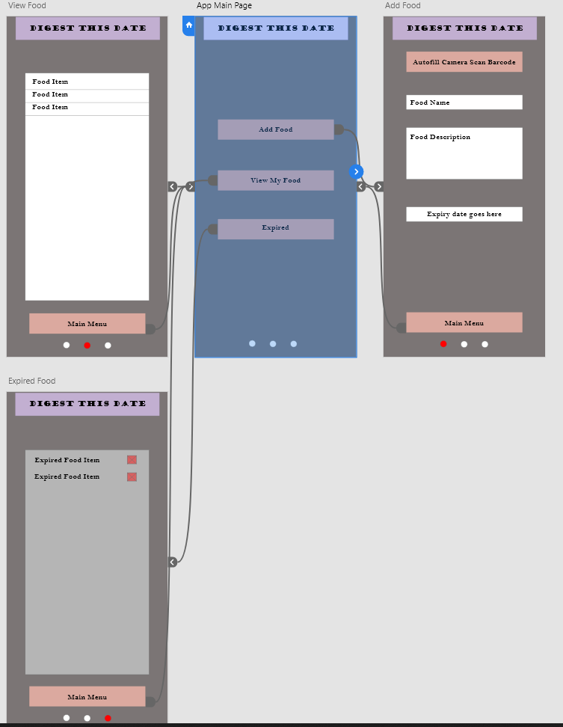

Live Prototype Video Uploaded to YouTube 30 seconds

<https://youtu.be/dZejvBrDOCY>